Chapter 19, Solution 50.

To get a and c, consider the circuit below.
I₁=0 2 s I₂

+ +

V₁ 4/s V2 - -

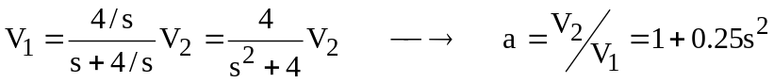

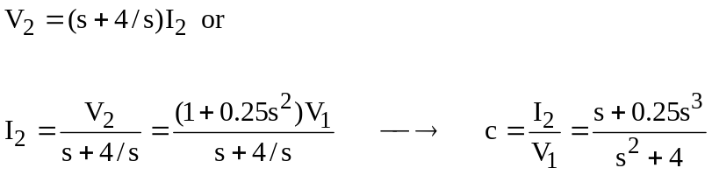

To get b and d, consider the circuit below.

I₁ 2 s I₂

+ +

V₁=0 4/s V₂
- -

